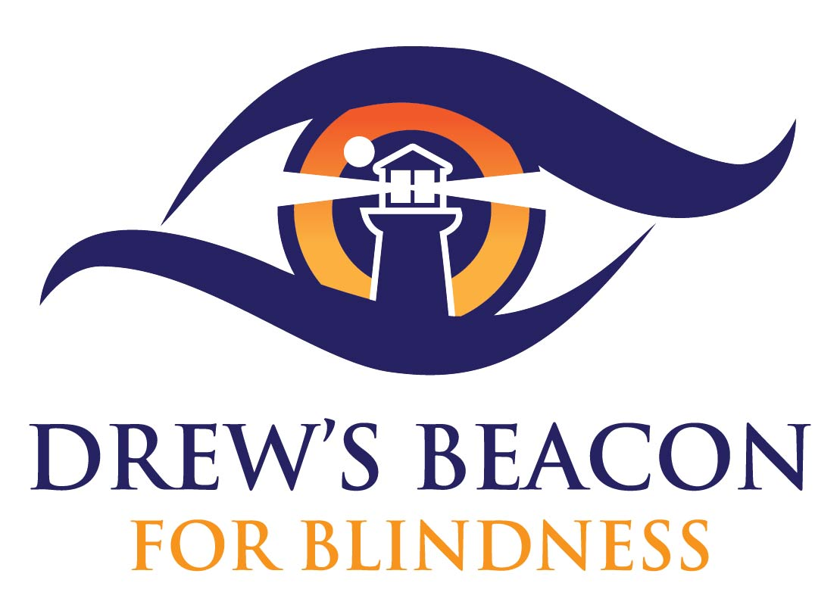
VISIONARY GRANT

Grants for Teachers and Coaches of Visually Impaired and Blind Students

Drew’s Beacon for Blindness (DBB) is proud to announce grant opportunities for teachers or coaches of visually impaired or blind students. Drew’s Beacon for Blindness is a non-profit 501(c)(3) organization in the Philadelphia area that supports the blind in Pennsylvania, New Jersey and Delaware. Our goal is to fund research in order to find a cure for LCA-CRX blindness while supporting local schools and organizations for the blind and visually impaired.
DBB is planning on awarding grants at a maximum total of $3,000 for the 2019 - 2020 school year. The total amount of grants may change from year-to-year depending our fundraising success and other budgetary considerations. We do not wish to prescribe exact amounts for the grants, although we hope to help you in the most influential way and to impact a high number of students. The minimum grant amount award will be $100.00 for the 2019 - 2020 school year for any teacher, professional staff or coach that works with students who are blind or visually impaired. Applications will be accepted April 1, 2019 through May 31, 2019. Awards will be announced in July 2019 with the intention of fulfilling the grant by the upcoming school year. A member of DBB will work with the award recipient to procure all items in a timely fashion. For more information regarding the application process, please visit the Drew’s Beacon for Blindness website, www.drewsbeacon.org.

Visionary Grant-Application Information

DDB is planning on granting awards at a maximum total of $3,000 for the 2019 - 2020 school year. This amount may change from year-to-year depending our fundraising success and other budgetary considerations. We do not wish to prescribe exact amounts for the grants, although we hope to help you in the most influential way and to impact a high number of students. The minimum grant amount award will be $100.00 for the 2019 - 2020 school year for any teacher, professional staff or coach that works with students who are blind or visually impaired. Applications will be accepted April 1, 2019 through May 31, 2019. Awards will be announced in July 2019. For more information, e-mail Drew’s Beacon for Blindness at drewsbeacon@gmail.com.
For the 2019 -2020 grant program, the following criteria will be used:
- The applicant must be a teacher, professional staff or coach who works with visually impaired or blind students.
- Projects/resources must benefit the education or development of blind or visually impaired individuals.
- The successful applicant will provide a project completion summary report by December 31, 2019. This summary report should include pictures or videos that can be used by Drew’s Beacon for Blindness publically. Applicants are responsible for distribution and submission of authorization forms of all pictured individuals permitting the release of the media to DBB.
- The deadline for application is May 31, 2019. Please submit applications to drewsbeacon@drewsbeacon.org.
Please read through these procedures and considerations before starting your application.
- All applications must be submitted with permission from the school principal or head of organization.
- A member of DBB will work with the award receipt to procure all items in a timely manner.
- Drew’s Beacon for Blindness reserves the right to publicize all grant programs.
- Funds cannot be used toward personal honorariums.
- An anonymized review of your proposal will be conducted by Drew’s Beacon for Blindness board members.
- Projects will be evaluated on their necessity, originality, potential and lasting impact on students. DBB reserves the ultimate right to deny the any application.

Visionary Grant Application
Goal: To support local schools and organizations for the blind and visually impaired.
Thank you for your interest in applying for a 2019 -2020 Drew’s Beacon for Blindness Grant.

Please complete the following application and submit by e-mail to drewsbeacon@drewsbeacon.org. Please change the file name to “Your OrganizationDBBGrant”. You may also submit your application by mail to: Drew’s Beacon for Blindness, P.O. Box 7, Trumbauersville, PA 18970

Timelines:
4/1/19-5/31/2019: Grant Proposals Accepted
7/2019: Awards Announced
12/31/2019: Grant project end date and Project Completion Report Form due
Project/Resource Title:__________________________________________________________
Amount Requested: _______________________________
Contact Person:__________________________________________ Position Title:_________
Other Applicant Name(s): _______________________________________________________
School/Organization Name: _____________________________________________________ Principal’s/Head of Organization’s Name:__________________________________________
Contact Phone:________________________________________________________________
E-mail:_______________________________________________________________________

Applicant Signature:________________________________________________Date:_________
Principal/Head of Organization Signature:______________________________ Date:_________
Visionary Grant Application

Agreements: Upon acceptance of a Grant Award by Drew’s Beacon for Blindness, you agree to do the following:
- Submit a Project Completion Report Form to the Foundation by December 31, 2019.
- Submit digital pictures of the project to Drew’s Beacon for Blindness for publicity use.

Position and Title of applicant(s)(No names of people/schools/organizations on this page): ______________________________________________________________________________
______________________________________________________________________________
Amount Requested: _________________
Number of Blind or Visually Impaired Students Served: __________ Grade Level(s): _________

Project or Resource Details--Please provide the following information.
1. Project/Resource Title: ____________________________________________________
2. Project/Resource Description: ______________________________________________
_______________________________________________________________________
3. Necessity of Project/Resource:______________________________________________
_______________________________________________________________________
4. How will this project/resource positively impact your students?__________________
_______________________________________________________________________
5. What lasting impact will this project/resource have either for your students or for your institution?__________________________________________________________
_______________________________________________________________________
6. How will you evaluate if this project/resource was beneficial to your students and/or organization?____________________________________________________________
______________________________________________________________________________

Visionary Grant Application

Project/Resource Budget:
Provide a detailed listing of all expenses you expect to incur in connection with this project or purchase of resources.
If more space is needed, please attach an additional sheet. You also may wish to attach catalog pages to clarify desired purchases.

Item | Supplier | Unit Cost | Total Cost
Total

Please provide any helpful explanations of project/resource expenditures:

